國立彰化女中110年度雙語班英文聽力試題參考範例
(此為參考範例，試題仍以當日應試考卷為主)
Part A
Look at the pictures below. For each, you will hear one or more questions or statements. Write down the letter of the best answer.

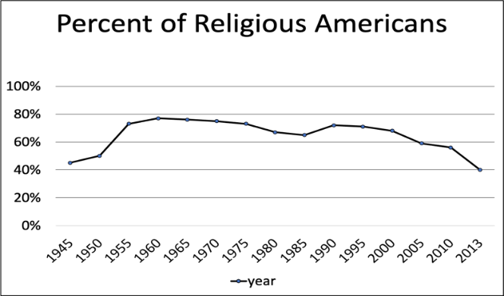

1. Which of the following sentences about the graph are true?
(A) Religion has been declining in the US since the 1940s.
(B) There was a sharp rise in those who had a religion in the 1960s.
(C) Fewer people were spiritual in 2013 than at any other time on the chart.
(D) Religion is beginning to gain popularity again
Answer: C

Part B
In Part B, you will hear several questions or statements. Choose the best response or reply.
1. I need someone to look after my infant tomorrow.
(A) I’ll be happy to walk your dog for you!
(B) I can certainly help care for your baby.
(C) No problem. I’ll clean your whole house.
(D) Sure. Where should I go to get it fixed?
Answer: B

Part C
In Part C, you will hear one or more conversations between a man and a woman, and then a question following each conversation. Choose the best answer to that question.
W: Let’s go further down into the cave. Watch your step and grip the rope.
M: OK. It is narrow here.
W: Don’t worry, it will open up soon. Aha! Here we are.
M: Are these the drawings? They look so old.
W: They are, but the cave has kept them in good shape. You can still see the shields in the hands of the people.
M: That’s amazing. So, how old are they?
W: These drawings are probably 17,000 years old.
M: Whoa… unbelievable!
1.What does the woman tell the man to do at first?
(A) Hold on tightly to something.
(B) Shine a light in the cave.
(C) Jump over some things in his way.
(D) Crawl on his hands and knees.

Answer: A

Part D
In Part D, you will hear one or more passages. Choose the best answers to those questions.

Passage 1 (Read questions 1 and 2 before listening to Passage 1)

W: Would I want to have a clone of myself? This is a question I considered while I was reading The House of the Scorpion, and I kept thinking about it once I’d finished, too. In the book, Matt is the clone of a powerful man called El Patrón. Although El Patrón provides for Matt and Matt comes to love him, El Patrón is actually responsible for many terrible things. When Matt learns about this, he must think about what that means about himself. Is he also doomed to be a bad person?
This book was written for kids, but I like that the author doesn’t treat us like we’re stupid just because we’re young. She gives us a lot of interesting ideas to think about. In the end, I like her message that you have power over your own choices, no matter who or what people expect you to be.
1. Who is the speaker?
(A) A college professor of biology.
(B) The clone of someone important.
(C) A junior high school student.
(D) The author of a children’s book.
2. How does the speaker feel about Matt?
(A) She thinks he’s a terrible person.
(B) She is interested in his choices.
(C) She is jealous of his family.
(D) She has come to love him.
Answer: CB

